# Homework: ASP.NET MVC Essentials

## Make empty controllers

Your task is to write empty controllers.

You should have the following controllers:

* HomeController – Here you should write the home page actions
* AccountController – This is the default AccountController. It is not necessary to change it.
* TweetsController – Here you should write all actions related to the tweets
* UsersController – Here you should write profile and edit actions…
* NotificationsController – All things about notifications should be in this controller.

## Write “Application home page”

Your task is to write controller, actions and views for the home page.

Application home page should list all tweets by all users, chronologically. Make action to work with paging. Implement paging in the view. Display only 10 tweets on page. The page size cannot be changed.

Use **ViewModels** to display only necessary information about the tweet.

Every tweet should have favorite, retweet, report, reply and share buttons.

## Write user home page

The user home page should display all tweets created by the followed users. Logged in users cannot access the application home page. When the user is logged in the home page should display only the tweets that are created by followed users.

Logged in users can post new tweet. Make form in the user home page for posting new tweet. Make the action for the posting new tweet in TweetsController.

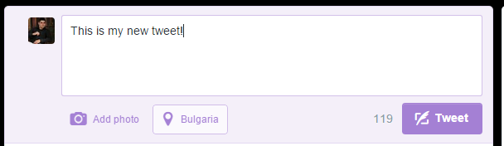

## Write user public profile page

Each user should have a public profile page. Profile have own tweets, following users, followers and favorite tweets.

You can see the twitter profile page for example.

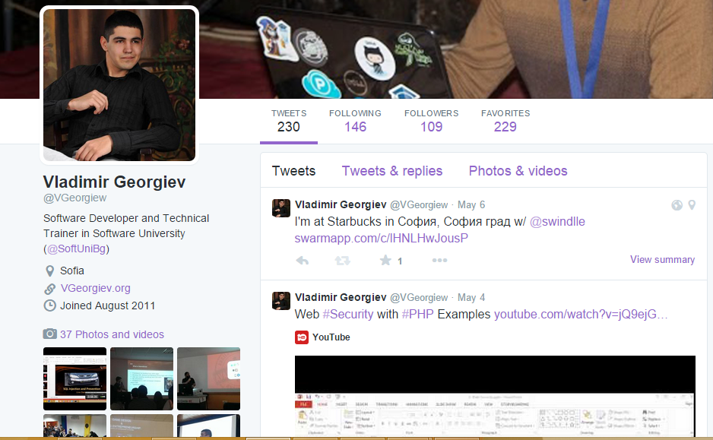

## Write notifications page

* Users receive notifications for retweet, favourite tweet and for new followers.
* The notification holds content, date and user.

Make controller for notifications and actions for all and only one notification. You should create and views for every action.

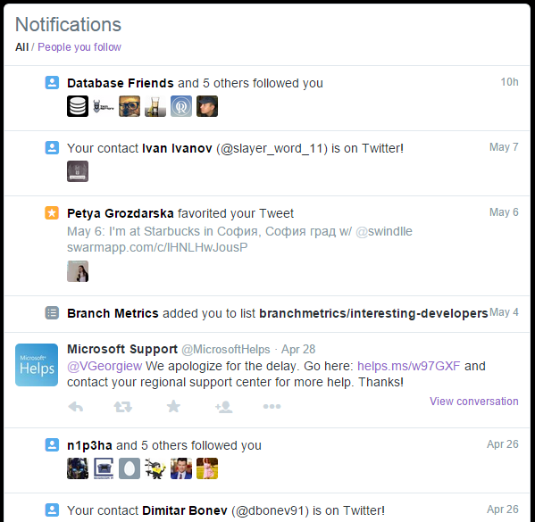

## Write user edit profile page

Your task is to write edit profile page. Every user can edit its own profile.